Book
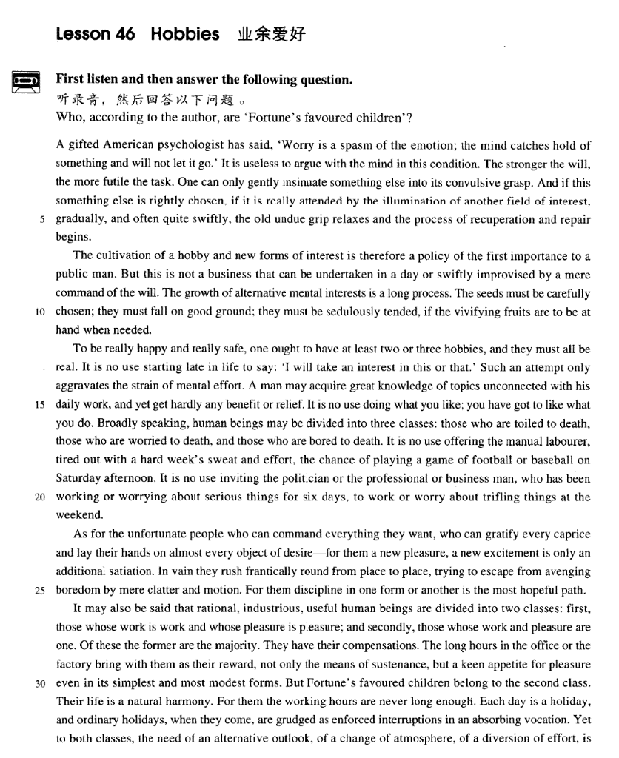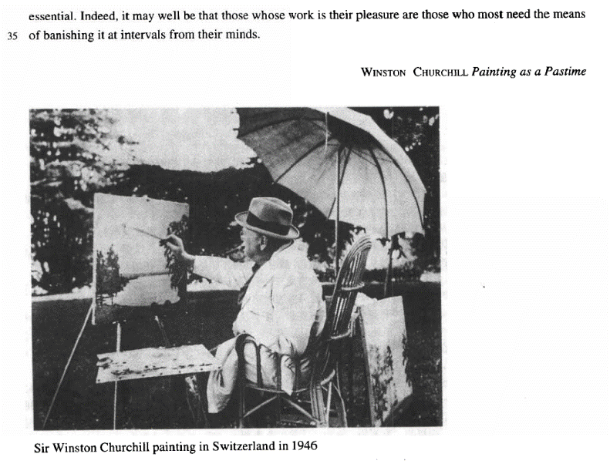

课文
A gifted American psychologist has said,'Worry is a spasm of the emotion; the mind catches hold of something and will not let it go.'
一位天才的美国心理学家曾经说过“烦恼是感情的发作，此时脑子纠缠住了某种东西又不肯松手。”

It is useless to argue with the mind in this condition.
在这种情况下，你又和头脑争吵让它松手是无济于事的。

The stronger the will, the more futile the task.
这种意志越是强烈，这种尝试越是徒劳。

One can only gently insinuate something else into its convulsive grasp.
你只能缓和而巧纱地让另一种东西进入痉挛僵持的头脑中。

And if this something else is rightly chosen, if it is really attended by the illumination of another field of interest, gradually, and often quite swiftly, the old undue grip relaxes and the process of recuperation and repair begins.
如果选得合适，而且的确受到别的领域的情趣的启迪，那么渐渐地，往往也是很顺利地，原先不适当的紧张就会松弛下来，恢复和修整的过程就会开始。

The cultivation of a hobby and new forms of interest is therefore a policy of the first importance to a public man.
因此，对一个从事社会活动的人来说，培养一种业余爱好和各种新的兴趣是关等重要的作法。

But this is not a business that can be undertaken in a day or swiftly improvised by a mere command of the will.
但这并非一日之功，也不是单凭一蹴而就的事。

The growth of alternative mental interests is a long process.
精神上多种情趣的培养是一个长期的过程。

The seeds must be carefully chosen; they must fall on good ground; they must be sedulously tended, if the vivifying fruits are to be at hand when needed.
要想在需要的时候可随手摘取充满生机的果实，那就必然从选良种做起，然后将其植入肥沃的土地，还需要勤勉地护理。

To be really happy and really safe, one ought to have at least two or three hobbies, and they must all be real.
一个人要想真正感到幸福和平安，至少应有两三种爱好，而且都比较实际。

It is no use starting late in life to say: 'I will take an interest in this or that.'
到了晚年才开始说：“我会对这些人或那个人发生兴趣”，

Such an attempt only aggravates the strain of mental effort.
已没有用了。这种愿望只能加剧精神紧张。

A man may acquire great knowledge of topics unconnected with his daily work, and yet get hardly any benefit or relief.
一个人可能会获得与其日常工作无关的某些课题的渊博知识，而没有从中得到什么实益或宽慰。

It is no use doing what you like; you have got to like what you do.
干你所喜欢的事是没有用的，你喜欢你所干的事。

Broadly speaking, human beings may be divided into three classes: those who are toiled to death, those who are worried to death, and those who are bored to death.
泛泛地说，人可以分为3类：劳累至死的人、忧虑至死的人、无聊至死的人。

It is no use offering the manual labourer, tired out with a hard week's sweat and effort, the chance of playing a game of football or baseball on Saturday afternoon.
对于流汗出力干了一周苦活的体力劳动者来说，让他们在星期六下午再踢足球或打垒球是不合适的。

It is no use inviting the politician or the professional or business man, who has been working or worrying about serious things for six days, to work or worry about trifling things at the weekend.
同样，对于为严肃的公务操劳或烦恼了6天的政界人士、专业人员、商人来说，在周未再让他们为琐事而动脑子和忧虑也是无益的。

As for the unfortunate people who can command everything they want, who can gratify every caprice and lay their hands on almost every object of desire -- for them a new pleasure a new excitement is only an additional satiation.
至于那些能任意支配一切的“可怜的人”，他们能够恣意妄为，能染指一切追求的目标；对这种人来说，多一种新的乐趣、多一种新的刺激只是增加一分厌腻而已。

In vain they rush frantically round from place to place, trying to escape from avenging boredom by mere clatter and motion.
他们到处奔乱跑，企图以闲聊和乱窜来摆脱无聊对他们的报复，但这是徒劳的。

For them discipline in one form or another is the most hopeful path.
对他们来说，用某种形式的纪律约束他们一下才能有希望使他们走上正道。

It may also be said that rational, industrious, useful human beings are divided into two classes: first, those whose work is work and whose pleasure is pleasure; and secondly, those whose work and pleasure are one.
也可以这样说，理智的，勤劳的、有用的人可以分为两类：第一类是他分清工作是工作，娱乐是娱乐的人；第二类人的工作和娱乐是一回事。

Of these the former are the majority.
这两类人当中，第一类人是大多数。

They have their compensations.
他们能够得到补偿。

The long hours in the office or the factory bring with them as their reward, not only the means of sustenance, but a keen appetite for pleasure even in its simplest and most modest forms.
在办公室或工厂里长时间工作给他们带来了酬劳，这不仅是谋生的手段，而且还带来了寻找乐趣的强烈欲望，那怕是最简单的、最低等的乐趣。

But Fortune's favoured children belong to the second class.
但是，命运之神的宠儿是第二类人。

Their life is a natural harmony.
他们的生活是一种自然的和谐。

For them the working hours are never long enough.
对他们来说，工作时间总不会太长。

Each day is a holiday, and ordinary holidays, when they come, are grudged as enforced interruptions in an absorbing vocation.
每天都是假日，而通常的假期来到，他们却惋惜这假期强制打断了他们埋头从事的工作。

Yet to both classes, the need of an alternative outlook, of a change of atmosphere of a diversion of effort, is essential.
然而对这两种人来说，都需要换一换脑子，改变一下气氛，转移一下注意力，这是不可缺少的。

Indeed, it may well be that those whose work is their pleasure are those who most need the means of banishing it at intervals from their minds.
说实在的，把工作当作享受的那些人最需要每隔一段时间把工作从头脑中撇开。

词汇讲解

gifted
- gifted ['gɪftɪd] adj. 有天才的，有天赋的
gifted adj. 有天才的，有天赋的
gift n. 礼物；天赋；赠品

【近义词】
talented adj. 有才能的；多才的
talent n. 才能；天才；天资

【近义词】
natural / born adj. 天生的
- He is a ~ ~ ~ leader.

【词组】表达“有天赋的”：
have a gift / an aptitude for … 在…方面有天赋
- Mozart had a gift for music.
- Mozart had an aptitude for music.

insinuate
- insinuate [ɪn'sɪnjueɪt] v. 暗示；使悄悄地潜入
insinuate 含义1：暗示
- What are you trying to insinuate?
- Are you insinuating that I smell?

【近义词】表达“暗示”：
imply v.
suggest v.
intimate v.
hint v.

insinuation n.
implication n.
suggestion n.
intimation n.
hint n.

insinuate v. 含义2：to get into a situation or position by behaving in a way that is not sincere 使悄悄地潜入……之中
insinuate A into B 使A潜入B之中
- Over the years she insinuated herself into the great man’s life.
- He has ways of insinuating his ideas into the brains of his followers.

grip
- grip [grɪp] n. 紧握，抓牢；理解，掌握
【同义词】
grip / grasp
- Don’t loosen your grip on the rope or you’ll fall.
- I tightened my grip on the handrail.
- She has a sound grip / grasp of English.

【同根词】
gripping / absorbing adj. 引人注意的
- a gripping / absorbing detective novel

aggravate
- aggravate ['ægrəveɪt] v. 使恶化
- The pain will be aggravated by coughing.

【近义词】
compound vt. 使加重；使恶化
- Their domestic problems were compounded by stress at work.

exacerbate vt.使恶化；使加剧；使加重
- Ironically, the government’s reassurances may have exacerbated fear about the disease.

【近义词】表达“主语本身在恶化”：vi.
deteriorate vi. 恶化，变坏
degenerate vi. 退化；堕落
go downhill 每况愈下; 走下坡路; 恶化; 衰落

【扩展】表达“减轻痛苦”：
relieve
alleviate

【扩展】表达“改善”：
ameliorate
improve
better
enhance

gratify
- gratify ['grætɪfaɪ] v. 满足，使满意
- be gratified to see / hear / learn ... 满意的…
- John was gratified to see the improvement in his mother’s health.
- gratify one’s whims / caprices 满足了某人的…

【近义词】
satiate …vt. 充分满足；使厌腻
- Nothing seems to satiate people’s need for gossip.

cater to / for… 迎合…

【同根词】【近义词】
gratification
satisfaction
satiation

avenge
- avenge [ə'vendʒ] v. 为……报仇
- He has devoted the past five years to avenging his daughter’s death.

avenge oneself on sb. 向某人报仇
- She avenged herself on her father’s killers.

【同义词】
revenge
- revenge one’s death
- revenge a defeat
revenge oneself on sb. 向某人报仇
- Eric wanted to revenge himself on John for the insult.

【近义词】
retaliate vi. 报复；反击；复仇
- The British government retaliated by breaking off diplomatic relations.
retaliate against …向…报仇
- The army began to retaliate against the civilian population.

get / pay sb. back (for…) （普通表达）报复
- This time you beat me, and sometimes I’ll get / pay you back (for this).

get even 报复
get even with sb. 向某人报复
- What can I do to get even with him?

grudge
- grudge [ɡrʌdʒ] v. 怨恨，不愿意
grudge v. 英文解释：feel resentful about sth; do or give sth. very unwillingly 怨恨， 不愿意
grudge + n. / doing 怨恨，不愿意做某事
- He grudges her earning more than he does.
- He grudges paying taxes.
- He grudges the money he pays in tax.
- There are times when we would willingly give everything we possess to save our lives, yet we might grudge paying a surgeon a high fee for offering us precisely this service.

【同根词】【近义词】
grudging
reluctant
unwilling

【名词形式】
grudge n. 恶意，怨恨
have / bear / hold a grudge 怀恨在心
- 托福听力真题：
A．She has a bad memory.
B．She's quick to forgive people.
C．Her feelings are easily hurt.
D．She doesn't get angry very often.
- W: I wish I hadn’t hurt Mary’s feelings like that. You know I’ve never meant to.
- M: The great thing about Mary is that she doesn’t hold a grudge. By tomorrow she’ll have forgotten all about it.
- Q: What does the man say about Mary?
- Answer: (B) She's quick to forgive people.

课文讲解

（标题）

Hobbies

知识点（1）课文作者介绍
Winston Churchill (1874~1965)
British politician and Prime Minister, widely regarded as the greatest British leader of the 20th century.
His courage, decisiveness, political experience and enormous vitality enabled him to lead the country through the Second World War.
Churchill was also known for the many books on British history and politics he wrote throughout his life.
His command of the English language not only made him a great orator but earned him the Nobel Prize for literature in 1953.

（第一段）

A gifted American psychologist has said,'Worry is a spasm of the emotion; the mind catches hold of something and will not let it go.'

语法分析：
A gifted American psychologist has said, 'Worry is a spasm of the emotion; the mind catches hold of something and will not let it go.（直接引语）'

知识点（1）
【近义词组】表达“紧紧握住”：
catch hold of …
grip / seize / clutch / clasp

【辨析】
get hold of 英文解释：find sb. or obtain sth. 找到某人、得到某物
- Where can I get hold of some stamps?
- Could you tell me how I can get hold of a doctor?

知识点（2）
let … go 放开、松开
= release
- Please release me, let me go. For I don't love you anymore. To waste our lives would be a sin. Release me and let me love again.

It is useless to argue with the mind in this condition.

语法分析：
It（形式主语） is useless to argue with the mind in this condition（to … 真正主语）.

知识点（1）【课文句型提炼】
it is useless / futile / pointless + to do / doing … 做某事没用

【扩展】【近义词组】
it’s a waste of time doing … 做某事是浪费时间
it’s no use doing …做某事没用
there is no use (in) doing …
it’s no good doing …
there is no good doing …
there is no point (in) doing …

The stronger the will, the more futile the task.

语法分析：补全
The stronger the will is（比较状语从句）, the more futile the task will be.

知识点（1）Lesson03-09、Lesson 03-43、Lesson 03-55比较级（10）
语法：“越…越…”比较
1）.两个the 分别放在句首，前半句从句，后半句是主句，从前往后翻译
- The harder they worked(前半句从句，类似条件状语从句) the hungrier they became. （后半句是主句）
- The more he gets, the more he wants
- The harder you work, the greater progress you will（时态：主将从现） make.
- It seems that the further cats fall, the less they are likely to injure themselves.

- 主句倒装
- The younger the child is （从句）, the more is the child’s need of sleep. （主句，倒装）
- The more democracy spreads, the stronger become（倒装） the forces of peace.

- 如果谓语动词是be动词，这种句型可省略:
- The younger the child is, the more is / will be the child’s need of sleep.
- The younger the child, the more the child’s need of sleep. （be动词省略）

- The higher the standard of living, the greater the amount of paper used. （be动词省略）
- The higher the standard of living is, the greater is / will be（倒装） the amount of paper used.

- The stronger the magnet, the greater the number of lines of magnetic force. （be动词省略）
- The stronger the magnet is, the greater is （倒装）the number of lines of magnetic force.

- The greater the percentage of such customers, the weaker the argument’s evidence as an indication of customer satisfaction with the change.
- The greater the percentage of such customers is, the weaker is the argument’s evidence as an indication of customer satisfaction with the change.

- 课文写法替换：Lesson03-44
- Needless to say, the bigger the risk an insurance company takes, the higher the premium you will have to pay.
- Needless to say, the bigger the risk an insurance company takes is, the higher will be（倒装） the premium you will have to pay.

2）.第一句the加比较级放在句中，第二句the加比较级放在句首，只能先翻译后半句，再翻译前半句
- They became (the) hungrier （前半句是主句）the harder they worked.（后半句是从句）
- I play the piano (the) better（主句）, the more（从句） I practice.
- The more（从句） I practice, the better（主句） I play the piano.

- A compound is considered the more stable（主句）, the smaller（从句） its potential energy.

- We are so familiar with the fact that man ages, that people have for years assumed that the process of losing vigour with time, of becoming more likely to die（主句） the older we get（从句）, was something self-evident, like the cooling of a hot kettle or the wearing-out of a pair of shoes.
- A telescope would have to be as far away as the planet Jupiter to look for life in outer space, because the dust becomes thinner（主句） the further we travel（从句） towards the outer edges of our own solar system.

One can only gently insinuate something else into its convulsive grasp.

知识点（1）
insinuate A into B 使A潜入B之中

And if this something else is rightly chosen, if it is really attended by the illumination of another field of interest, gradually, and often quite swiftly, the old undue grip relaxes and the process of recuperation and repair begins.

语法分析：
And if this something else is rightly chosen（if... 条件状语从句1）, if it is really attended（随同；陪同） by the illumination of another field of interest（if... 条件状语从句2）, gradually（时间状语）, and often quite swiftly（插入语）, the old undue grip relaxes and the process of recuperation and repair begins.

知识点（1）
含义1：
attend v. 出席；参加
- attend the meeting
- attend college

含义2：
attend v. 照顾
- She is attended by a 24-hour nursing staff.

含义3：
attend to sth. 处理；对付；照料
= deal with sth.

含义4：
attend v. to be with sb and help them 随同；陪同
- The queen was attended by her ladies-in-waiting.
- The occasion was attended by an air of sadness.

（第二段）

The cultivation of a hobby and new forms of interest is therefore a policy of the first importance to a public man.

语法分析：
The cultivation of a hobby and new forms of interest（后置定语） is therefore a policy of the first importance（后置定语） to a public man.

知识点（1）【词汇】
cultivation n. 培养；耕作；耕种；教化；文雅
cultivate vt. 培养；陶冶；耕作
- Most of the world’s fertile land is already cultivated.
- cultivate vegetables / peonies

cultivate v. develop / build up 培养；
- cultivate hobbies
- cultivate a love of art
- cultivate good study habits

知识点（2）【词汇】
policy n.政策；方针
- Honesty is the best policy.

知识点（3）Lesson03-32 介词of在句子中做的成分介词知识点（22）
【Part1】
语法：of + 名词 : 描述人或事物的特征
1、做后置定语。
- nothing of value = nothing valuable
- a matter of significance = a significant matter
- a ship of 46,000 tons
- a man of wide social relations
- This is a mission of importance.

2、在系动词后做表语。(be of)
- ... proved to be of great interest. = proved to be very interesting.
- It is of no use = it is useless.
- Her dress is of dark crimson.
- He is of a peculiar disposition.
- a man of middle height = The man is of middle height.
a girl of remarkable imagination = The girl is of remarkable imagination.

【Part2】
表达“头等重要的、至关重要的”：
of the first importance
of leading / primary / paramount importance
of vital / crucial importance

表达“次等重要的”：
of secondary importance

表达“同等重要的”：
of equal importance

But this is not a business that can be undertaken in a day or swiftly improvised by a mere command of the will.

语法分析：
But this is not a business（事情） that can be undertaken in a day（时间状语） or swiftly improvised by a mere command of the will（方式状语）（that ...定语从句）.

The growth of alternative mental interests is a long process.

知识点（1）【词汇】
alternative adj. 英文解释：different from the one you have and can be used instead 其他的，另外的
- Have you any alternative suggestions?
- alternative mental interests

alternative n. 二中择一；供替代的选择
alternative to sth.
- Is there a viable alternative to surgery?

have no alternative but to do… 别无选择，只能…
- I have no alternative but to report him to the police.

【辨析】
alternate adj. 轮流的，交替的
- I visit him on alternate Sundays.

The seeds must be carefully chosen; they must fall on good ground; they must be sedulously tended, if the vivifying fruits are to be at hand when needed.

语法分析：
The seeds must be carefully chosen; they must fall on good ground; they must be sedulously tended, if the vivifying fruits are to be（将来时） at hand when needed（时间状语从句）（if... 条件状语从句）.

知识点（1）
at hand 近在手边
- I always keep a dictionary close at hand.

by hand 用手
- The signature must be given by hand.

be in hand 在过程中
- The work is in hand, and will soon be completed.

on hand 有空、可以得到
- They are always on hand whenever you need them.

off hand 立即、立刻
- I can’t remember his phone number off hand.

（第三段）

To be really happy and really safe, one ought to have at least two or three hobbies, and they must all be real.

语法分析：
To be really happy and really safe（目的状语）, one ought to have at least two or three hobbies, and they must all be real.

It is no use starting late in life to say: 'I will take an interest in this or that.'

语法分析：
It（形式主语） is no use starting late in life（插入语） to say: 'I will take an interest in this or that.'（真正主语）

知识点（1）
it is no use doing 做某事没有用
- It’s no use crying over spilt milk.

知识点（2）
take an interest in …
= be interested in …

Such an attempt only aggravates the strain of mental effort.

知识点（1）【词汇】
strain: stress / tension / pressure n. 张力；拉紧；负担

A man may acquire great knowledge of topics unconnected with his daily work, and yet get hardly any benefit or relief.

语法分析：
A man may acquire great knowledge of topics unconnected with his daily work（后置定语）, and yet get hardly any benefit or relief.

知识点（1）【词汇】Lesson03-39
relief n. 宽慰，痛苦的缓解或解脱
- find a temporary relief 临时解脱
- permanent relief 永久解脱
- to my great relief 大为宽心宽心
- give immediate relief from pain 立刻缓解了疼痛

It is no use doing what you like; you have got to like what you do.

语法分析：
It（形式主语）is no use doing what you like（what… 宾语从句）（真正主语）; you have got to like what you do（what… 宾语从句）.

知识点（1） 名句
写作：Antimetabole 回环 / 倒复
- It is no use doing what you like; you have got to like what you do.
- Eat to live, not live to eat. —— Socrates
- Forty is the old age of youth, fifty is the youth of old age. —— Victor Hugo
- Where there is marriage without love, there will be love without marriage. —— Benjamin Franklin
- The reasonable man adapts himself to the world, the unreasonable man persists in trying to adapt the world to himself. Therefore, all progress depends on the unreasonable man. —— G. B. Shaw
- So let us begin anew —remembering on both sides that civility is not a sign of weakness, and sincerity is always subject to proof. Let us never negotiate out of fear, but let us never fear to negotiate. —— John F. Kennedy
- And so, my fellow Americans, ask not what your country can do for you; ask what you can do for your country. —— John F. Kennedy

Broadly speaking, human beings may be divided into three classes: those who are toiled to death, those who are worried to death, and those who are bored to death.

语法分析：
Broadly speaking（状语，一般来说）, human beings may be divided into three classes: those who are toiled to death（同位语1）, those who are worried to death（同位语2）, and those who are bored to death（同位语3）.

知识点（1）【词汇】
broadly adv.
= generally

Broadly speaking 一般来说
= generally speaking

- idiom，不用考主语统一
- Strictly speaking（严格来说）, the whale isn’t a fish. Judging from his face, he must be ill.
- To make a long story short（长话短说）, he wanted money, and tried to get it without working.
- But as they are about to return, an unprecedented storm descends on the area and blocks their way home. To make things worse（更糟的是） something unexpected happens.

知识点（2）【词汇】
toil v. 英文解释：to work very hard for a long period of time 长期辛苦工作，苦干
- Farm laborers have to toil in the fields all day.
- He was toiled to death.
- I have nothing to offer, but blood, toil（n.辛劳、辛苦）, tears and sweat.

知识点（3）【课文仿写】
- Gre写作范文：
- Broadly speaking, leaders may be divided into two classes: those who are created by demands placed upon them, and those who are ‘self-created’ through hard work and achievements. Fortune’s favored children belong to the former, whereas the latter, I believe, are the majority.

It is no use offering the manual labourer, tired out with a hard week's sweat and effort, the chance of playing a game of football or baseball on Saturday afternoon.

语法分析：
It（形式主语） is no use offering the manual labourer, tired out with a hard week's sweat and effort（后置定语）, the chance of playing a game of football or baseball on Saturday afternoon（真正主语）.

知识点（1）
be tired out / exhausted 精疲力竭

知识点（2）
offer sb. sth. / sth. to sb. 给某人提供某事

It is no use inviting the politician or the professional or business man, who has been working or worrying about serious things for six days, to work or worry about trifling things at the weekend.

语法分析：
It（形式主语） is no use inviting the politician or the professional or business man, who has been working or worrying about serious things for six days（定语从句）, to work or worry about trifling things at the weekend（真正主语）.

（第四段）

As for the unfortunate people who can command everything they want, who can gratify every caprice and lay their hands on almost every object of desire -- for them a new pleasure a new excitement is only an additional satiation.

语法分析：
As for（至于） the unfortunate people who can command everything they want（定语从句）（who...定语从句1）, who can gratify every caprice and lay their hands on almost every object of desire（who...定语从句2）（As for… 介词短语做状语）—for them（状语） a new pleasure, a new excitement is only an additional satiation.

知识点（1）【词汇】
command v. 掌管，掌握
- command great wealth
- command a large vocabulary

知识点（2）【词汇】
gratify v. satisfy

知识点（3）
get / lay one’s hands on sth 得到某物
= obtain sth.
- I would read any book I could get / lay my hands on.

【辨析】
get / lay one’s hands on sb 英文解释：to catch sb. you are angry with 抓住惹你生气的人
- Just wait till I get / lay my hands on you!

In vain they rush frantically round from place to place, trying to escape from avenging boredom by mere clatter and motion.

语法分析：
In vain（状语，徒劳的） they rush frantically round from place to place, trying to escape from avenging boredom by mere clatter and motion（方式状语）（原因状语）.

知识点（1）【词汇】
in vain 英文解释：without success in spite of your efforts 徒劳
- Obviously all her complaints were in vain.
- Police searched in vain for the missing boy.

【近义词组】
to no avail 徒劳
- He rebooted my systems several times, but to no avail.

For them discipline in one form or another is the most hopeful path.

（第五段）

It may also be said that rational, industrious, useful human beings are divided into two classes: first, those whose work is work and whose pleasure is pleasure; and secondly, those whose work and pleasure are one.

语法分析：
It（形式主语）may also be said that rational, industrious, useful human beings are divided into two classes: first, those whose work is work and whose pleasure is pleasure（定语从句）（同位语1）; and secondly, those whose work and pleasure are one（定语从句）（同位语2）（that...主语从句）.

Of these the former are the majority.

知识点（1）【词汇】
majority 大多数
- sweeping / overwhelming / absolute / vast majority
- small / narrow majority

be in the majority 是大多数
- Surveys indicate that supporters of the treaty are still in the majority.
- 课文写法替换：
- Of course, the former are in the majority.

【近义词】
predominate 大多数
- In older age groups women predominate because men tend to die younger.
- 课文写法替换：
- Of course the former predominate.

They have their compensations.

知识点（1）【词汇】
- 课文写补全：
- They have their compensations for their hard work.

The long hours in the office or the factory bring with them as their reward, not only the means of sustenance, but a keen appetite for pleasure even in its simplest and most modest forms.

语法分析：
The long hours in the office or the factory bring with them as their reward（状语前置）, not only（不但） the means of sustenance, but（而且） a keen appetite for pleasure even in its simplest and most modest forms（状语）.

But Fortune's favoured children belong to the second class.

知识点（1）【词汇】
favour / favor vt. 喜爱偏爱
= prefer
- She favors her youngest child.

Fortune’s favored children 天之骄子

Their life is a natural harmony

- 课文写法替换：不如名词正式
- Their life is naturally harmonious.

For them the working hours are never long enough.

Each day is a holiday, and ordinary holidays, when they come, are grudged as enforced interruptions in an absorbing vocation.

语法分析：
Each day is a holiday, and ordinary holidays, when they come（时间状语从句）, are grudged as enforced interruptions in an absorbing vocation（后置定语）.

知识点（1）
be grudged as sth. 被当做……而耿耿于怀，拒绝接受
- He is spending his precious vacation in a country retreat and any visit now will be grudged as disturbance to his privacy.

知识点（2）【词汇】
enforce v. 强迫人们服从，执行
- The main role of the police is to uphold and enforce the law.

enforced adj. 被迫的，自己无法控制的
- enforced absence
- enforced isolation

知识点（3）【词汇】
表达“职业”：
vocation
job
profession
occupation

【辨析】
vacation 假期

Yet to both classes, the need of an alternative outlook, of a change of atmosphere of a diversion of effort, is essential.

语法分析：
Yet to both classes the need of an alternative outlook（后置定语1）, of a change of atmosphere（后置定语2）, of a diversion of effort（后置定语3）, is essential.

知识点（1）【词汇】
diversion n. 英文解释：change in the direction or use of sth. 改变（方向或用途）
- the diversion of a ship
- the diversion of a stream
- This would result in massive diversion of funds.

Indeed, it may well be that those whose work is their pleasure are those who most need the means of banishing it at intervals from their minds.

语法分析：
Indeed（事实上）, it may well be that those whose work is their pleasure（定语从句） are those who most need the means of banishing it at intervals（插入语） from their minds（定语从句）（that… 表语从句）.

知识点（1）【课文句型提炼】
It may well be that … 很有可能

Indeed, it may well be that those who … are those who most need … at intervals …
其实，很可能那些……的人是最需要每隔一段时间….

- 造句：其实，很可能那些平时几乎不看病的人是最需要每隔一段时间从工作中抽空 (take time off from work) 做一次全面的体检 (have a thorough checkup)。
- Indeed, it may well be that those who hardly see a doctor are those who most need take time off from their work at intervals to have a thorough checkup.

